PARENTAL CONSENT FORM

I, _______________________________________, give my permission to Dr. Hyten and his staff to provide dental treatment for my child _________________________________________ in my absence.

Print Patient Name:_______________________________________________________

Signature:_______________________________________________________________

Relationship to Patient:____________________________________________________

Date:___________________________________________________________________

HIPPA PRIVACY ACT
PATIENT CONSENT FORM

I understand that, under the Health Insurance Portability & Accountability Act of 1996 (HIPPA), I have certain rights to privacy regarding my protected health information. I understand that this information can and will be used to:

- Conduct, plan, and direct my treatment and follow-up among the multiple healthcare providers who may be involved in that treatment directly and indirectly.

- Obtain payment from third-party payers.

- Conduct normal healthcare operations such as quality assessments and physician certifications.

I have been informed by you of your Notice of Privacy Practices containing a more complete description of the uses and disclosures of my health information. I have been given the right to review such Notice of Privacy Practices. I understand that this organization has the right to change its Notice of Privacy Practice from time to time and that I may contact this organization at any time to obtain a current copy of the Notice of Privacy Practices.

I understand that I my request in writing that you restrict how my private information is used of disclosed to carry out treatment payment or health care operations. I also understand you are not required to agree to my requested restrictions, but if you do agree then you are bound to abide by such restrictions.

I understand that I may revoke this consent in writing at any time, except to the extent that you have acted relying on the consent.

Print Patient Name:_______________________________________________________

Signature:_______________________________________________________________

Relationship to Patient:____________________________________________________

Date:___________________________________________________________________

APPOINTMENT CANCELLATION POLICY

We understand that unplanned issues can come up and you may need to cancel an appointment. If that happens, we respectfully ask for scheduled appointments to be cancelled at least 24 hours in advance.

Our doctor and hygienists want to be available for your needs and the needs of all our patients. When a patient does not show up for a scheduled appointment, another patient loses an opportunity to be seen. Although we have always had cancellations, more frequent occurrences have caused us to enforce a policy of charging for no-show appointments, and those appointments not cancelled within 24 hours. As of February 1, 2016, there will be a fee of $25.00 assessed if we do not receive a call to cancel an appointment.

Thank you for being a valued patient and for your understanding and cooperation as we institute this policy. This policy will enable us to open otherwise unused appointment to better serve the needs of all patients.

The Staff of Dr. Robert S. Hyten III D.M.D.

Print Patient Name:_______________________________________________________

Signature:_______________________________________________________________

Relationship to Patient:____________________________________________________

Date:___________________________________________________________________
FINANCIAL POLICY

Thank you for selecting Hyten Dental as your dental healthcare provider! Our primary goal is that you receive optimal treatment needed to restore and maintain your dental health. Therefore, if you have any questions or concerns about our financial policies, please do not hesitate to ask us.

Payment for services are due at the time services are rendered. We accept cash, personal checks, MasterCard, Discover, Visa, and Debit cards. We also offer interest free/low interest financing through CareCredit. Returned checks will have an additional fee of $25.00 added to the amount of the returned check.

We accept all insurance, however, we are currently In Network Providers for Delta Dental and Cigna. Your insurance policy is a contract between you, your employer, and the insurance company. We are NOT a party to that contract. Our financial relationship is with you, not your insurance company. We are happy to process your insurance claim if we have correct information regarding your insurance policy. Please be sure to know your insurance company's name, claims address, phone number, and group number. We will also need your member ID # and/or social security # to accurately check your insurance benefits and submit claims. Please be sure to advise us if this information changes at any time throughout the year, so our records stay current. You are responsible for all fees regardless of portions covered by your insurance. We will do our best to present you with the treatment plan estimate, however, it is only an estimate and not a guarantee of payment by your insurance company. Not all services are covered benefits in all contracts. Any amount not covered by your insurance company or any unpaid deductibles are due at the time of treatment. Any portion not paid by insurance will be your financial responsibility. Any balance due past 90 days may be subject to collections and you will be responsible for paying attorney fees and expenses of collecting charges due after 90 days.

We understand that temporary financial problems may affect timely payment of your balance. We encourage you to communicate any such problems to us so that we can assist you in the management of your account.

Again, thank you for choosing Hyten Dental! We appreciate your confidence in us and the opportunity to serve you!

Print Patient Name:_______________________________________________________

Signature:_______________________________________________________________

Relationship to Patient: _________________________________Date:______________

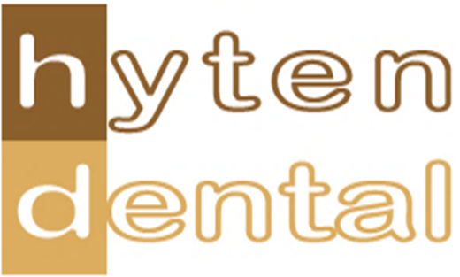

How did you come to find out about our practice? Please check all that apply below.
- Friend
- Family
- Co-worker
- Employer
- Church
- Social Event
- Our website
- Google
- Facebook
- TV ad
- Radio ad
- Newspaper ad
- Direct Mail ad
- School functions
- Other

If other, please explain! ______________________________________________________________________________________________________________________________________

Thank you for taking the time to give us your feedback!

